[TRM](https://www.espressif.com/sites/default/files/documentation/esp32-c3_datasheet_en.pdf)

[Baseline Schematic](https://www.digikey.com/en/htmldatasheets/production/9188192/0/0/1/esp32-c3-wroom-02-h4)

* Pg. 23 “Peripheral Schematic” Seems to be what we want
* 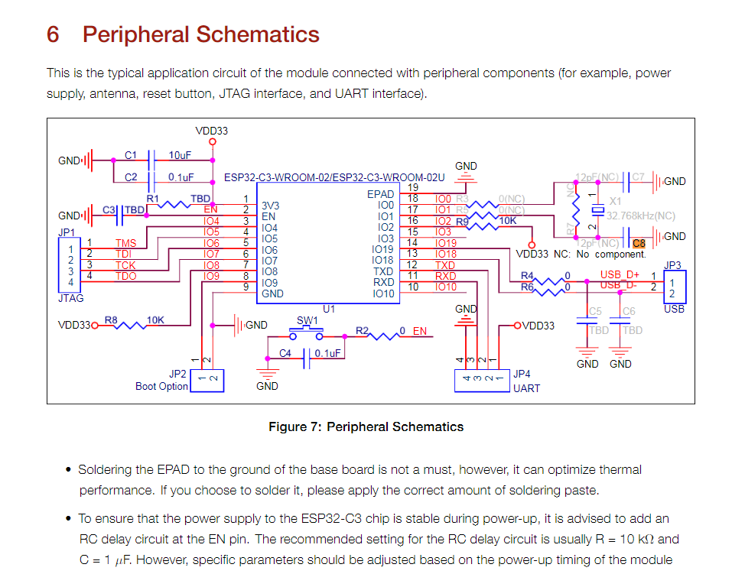

[Sample Schematic](https://github.com/AnalogLamb/esp32/blob/master/ESP-WROVER-KIT_SCH-3.pdf)

[Dev Board Schematic](https://dl.espressif.com/dl/schematics/SCH_ESP32-C3-DEVKITM-1_V1_20200915A.pdf)

[Boot Selection](https://docs.espressif.com/projects/esptool/en/latest/esp32c3/advanced-topics/boot-mode-selection.html)

[Antenna Details](https://espressif.github.io/esp32-c3-book-en/chapter_5/5.3/5.3.4.html)

[Internal USB Serial/JTAG Controller Console](https://docs.espressif.com/projects/esp-idf/en/stable/esp32c3/api-guides/usb-serial-jtag-console.html)

* Explains how to use the interna USB to serial for booting
* Need an external 5V source to have this work

[Schematic Checklist](https://docs.espressif.com/projects/esp-hardware-design-guidelines/en/latest/esp32c3/schematic-checklist.html)

* Shows the bootstrap pins
* 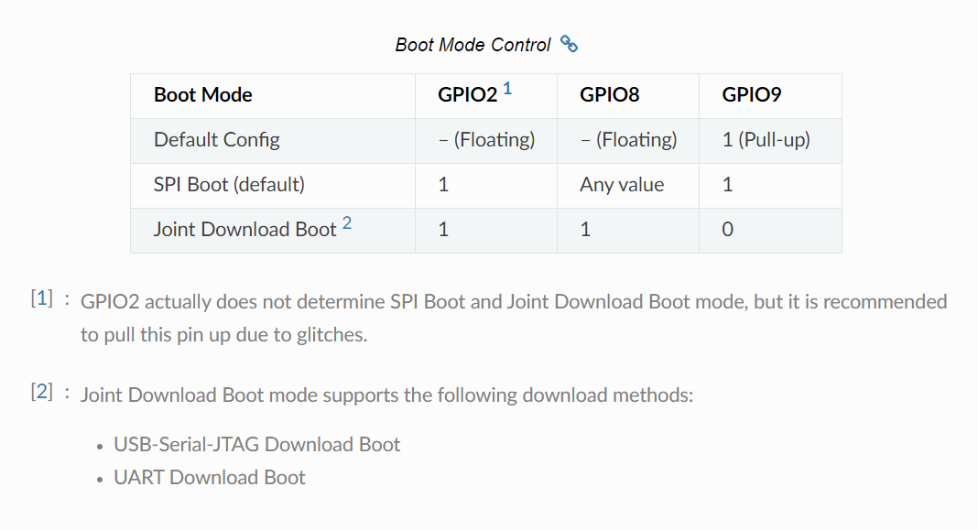
* Avoid GPIO 2, 8,9 because they are bootstrapped
* GPIO
* Added 22pF Caps on the D+/- Lines for the USB

[Datasheet](https://www.espressif.com/sites/default/files/documentation/esp32-c3-wroom-02_datasheet_en.pdf)

* Pinout Page 11 Accurate